Yasser Arafat’s “Moukata” Compound in Ramallah:
A Center for Controlling and Supporting Terrorism

Arafat’s compound in Ramallah houses the office of Fuad Shoubaki, the accounting administration of the Palestinian General Security Service. Shoubaki is the chief procurement and finance officer of the Palestinian Authority and was one of the key players involved in the “Karine A” arms smuggling affair.
Shoubaki’s previous office was located 100 meters south of Arafat’s office. Following the “Karine A” affair, Shoubaki was arrested and interrogated in the office of the Head of the General Intelligence Service Tiraawi, which is adjacent to Chairman Arafat’s office. This is one of the offices IDF forces entered as a part of the Wall of Defense operation (April, 2002).
Inside Tiraawi and Shoubaki’s office building, IDF forces found a large amount of weapons (including RPG launchers) which the PA is forbidden to possess, according to its agreements with Israel. IDF forces also found counterfeit money as well as documents belonging to Fuad Shoubaki. These prove that Shoubaki continued to operate “business as usual” in the Moukata compound, even after his involvement in the “Karine A” affair (January, 2002) was discovered.
Shoubaki is close to Chairman Arafat and often accompanies him as a part of official Palestinian delegations to Arab countries. He also holds private meetings in countries willing to support the Palestinian terrorist efforts, such as Iraq, which he visited in November 2001.
Fuad Shoubaki is also in charge of financing the “Fatah” branches, which carry out terrorist activities under a cover name – “the Al-Aksa Brigades”.
Evidence found by IDF forces in the course of the present operation in Ramallah established a clear link between Shoubaki and the Al-Aksa Brigades.
Original documents seized by the IDF in the “Moukata“ compound reveal that the Al-Aksa Brigades is an established organization, which holds official correspondence with Fuad Al-Shoubaki’s office in order for it to finance its planned operations. This money does not go merely to finance propaganda concerning terrorists involved in attacks, but also to control the planning of future attacks. One document captured in Ramallah, for example, is a request from Al-Aksa officials, dated September 16th, asking Shoubaki for money to prepare bombs – “the costs of making one explosive charge is at least 700 NIS. Each week, we require 5 to 9 charges for cells operating in the various regions”.
A handwritten document found in the same office, translates this request to monetary terms using a simple method of calculation: an average of 7 bombs a week = 5,000 NIS a week or 20,000 NIS per month.
Shoubaki also provided ongoing funding for the activity of the Al-Aksa Brigades in the Bethlehem region, when he transferred monthly salaries to the organization’s activists in the area. Also, he was involved in purchasing weapons, which were stolen towards the end of the year 2000 from an IDF base in the area. These weapons were later used to carry out attacks against Israeli civilians in the area of Jerusalem.
Shoubaki was active in other regions as well and had been involved in smuggling arms from Jordan and Egypt (via underground tunnels).
The Al-Aksa Brigades organization carried out suicide and “Self Sacrifice” (terrorist shooting) attacks in growing numbers in the last six months: After carrying out only two attacks towards the end of 2001, the organization adopted a more aggressive and intensive modus operandi involving suicide and shooting attacks. Al-Aksa carried out 4 attacks in January 2002 (in Hadera, Jerusalem and Tel-Aviv); 6 in Febuary (in Mehola, Army Base “80”, Jerusalem, and the Maccabim checkpoint); and 9 in March (in Netanya, Ashdod, Jerusalem, Tel Aviv, Kfar Saba and Efrat).
The growing rate of the attacks corresponds to the plan outlined in the document of September 16, 2001 (5 days after the September 11 attack in the U.S), for the preparation of a large number of explosive charges each month, for which Shoubaki was asked to provide the money.
The “Al-Aksa Brigades” is a cover name assumed by the Fatah to avoid responsibility for its terrorist activities. The organization’s activities are directed by Marwan Barghouti (head of the Tanzim in the West Bank), who passes concrete instructions to Al-Aksa operatives. The Al-Aksa Brigades has recently been declared a terrorist organization by the U.S.
The Al-Aksa Brigades planned infrastructure involves more than just bullets and bombs. An additional letter captured in Shoubaki’s office (see below) details an ambitious plan of this terrorist organization to create a factory for the manufacturing of heavy weapons. Among other things, purchasing a lathe (costing $25,000) and other machines needed to process the metal in order to manufacture weapons such as rockets and mortars. It is known that the Al-Aksa Brigades are producing rockets similar to the “Kassam” rockets made by the Hamas.
The required investment in the weapon factory is $100,000, and the ongoing expenses are measured at $15,000 per month. It is no wonder that these requests are being received by Shoubaki, the procurement and finance officer who seems to have a hand in everything.
The network established by Shoubaki includes Iran and Iraq on the one hand (countries which are a part of the “Axis of Evil”), and branches of the Fatah hiding behind the name “Al Aksa Brigades” on the other.
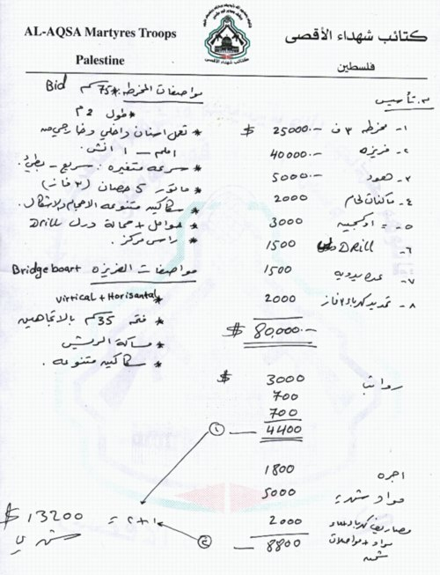

Fuad Shoubaki's Office's handling of the “Al Aqsa Martyrs Brigades”

Request for Financial Aid

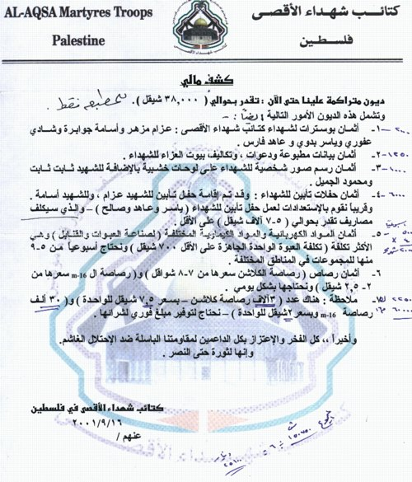

Translation:
Al Aqsa Martyrs Brigades
Palestine
Financial Report
The debts which we have accumulated until now are estimated to be NIS 38,000. The following are the details:
1. The cost of posters of the Al Aqsa Martyrs Brigades: Azam Mazhar, Usama Jubara, Shadi Afuri, Yasser Badawi, Ahed Fares (addition in handwriting of 2,000 shekels).
2. Costs of printed announcements, invitations and mourners shelters for martyrs (addition in handwriting of 1,250 shekels).
3. Cost of sticking photos of martyrs on wooden boards and also of the martyrs Thabet Thabet and Mahmud Al Jamil (addition in handwriting of 1,000 shekels).
4. Cost of memorial ceremonies for the martyrs. Memorial ceremonies were held for the martyr Azam and the martyr Usama (addition in handwriting of 6,000 shekels).
5. Costs of electricity products and various chemical materials (for manufacture of explosive charges and bombs). This is the greatest expenditure (the cost of one ready explosive charge is 700 shekels at least). We require on a weekly basis 5 – 9 explosives charges for squads in various areas (addition in handwriting of 5,000 shekels per week x 4 = 20,000 shekels per month).
6. The cost of bullets. The cost of a Kalashnikov bullet is 7 – 8 shekels, and an M-16 bullet costs 2 – 2.5 shekels. We need bullets on a daily basis.
7. Note: there are 3,000 Kalashnikov bullets at a cost of 2 shekels per bullet. We require that you transfer to us immediately a sum of money for us to purchase them (addition in handwriting of 22,500 shekels for kalashnikov bullets and 60,000 shekels for M-16 bullets).
In conclusion, all the glory and pride to those supporting the brave resistance against the oppressive occupation.
From the revolution until victory.
Palestinian Al Aqsa Martyrs Brigades
16 September 2001
Addition in handwriting: 25,000 Dinar = 150,750:6

Arafat DIRECTLY approves allocation of funds to terrorists
The following is an order of Arafat to the PA "Finance Ministry" dated September 19, 2001 (8 days after the Bin Laden attacks in the US) to grant $600 to three terrorists, including two senior activists of the Fatah infrastructure in Tulkarm (one of them was the head of the terror infrastructure, Ra'ed Al-Karmi, and the second is Ziad Da'as -- head of the group behind the killing attack at the Bat-Mitzvah party in Hadera). The order is given in Yasser Arafat's handwriting, on an official letter of the Presidential Bureau in the PA.
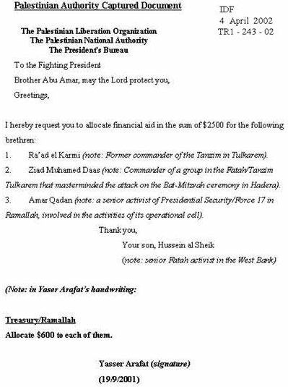

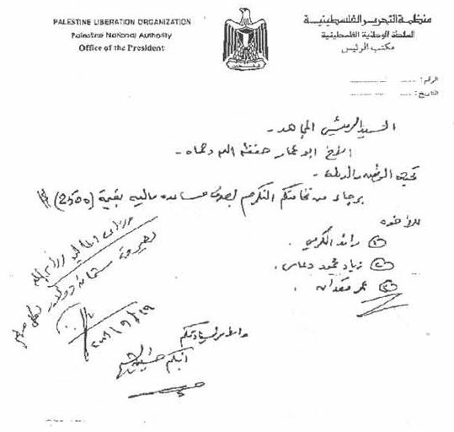

More proof that Arafat is the Head Terrorist
The following is an order of Arafat to the PA "Finance Ministry" dated January 7, 2002, to grant $350 to each of the 12 Fatah activists whose names are listed on the document. These are members of the Fatah/Tanzim terror infrastructure in the Tulkarm district, who are involved in terrorist attacks. The approval is given in response to a request of Ra'ed Karmi, who led (until his death) the Fatah/Tanzim terrorist infrastructure (which perpetrated many murderous attacks since the beginning of the present conflict in September, 2000) in the Tulkarm area.

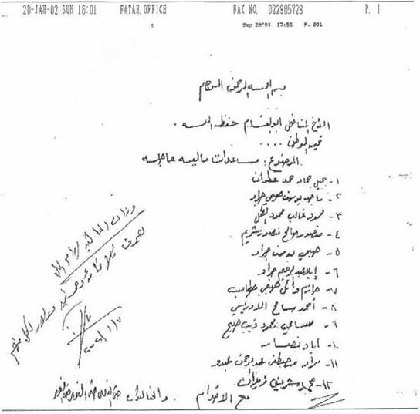

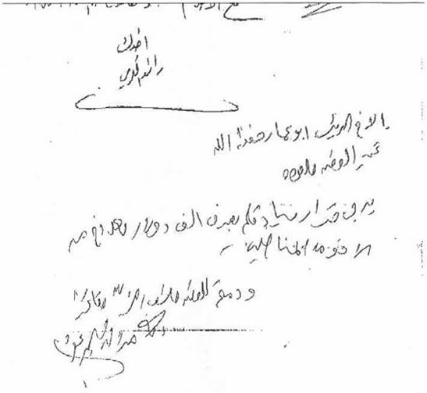

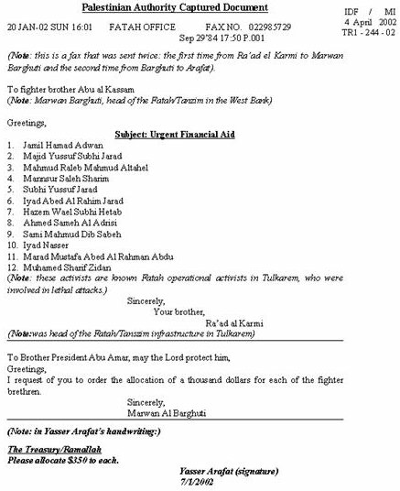

Report on Arafat's Fatah in Tulkarm

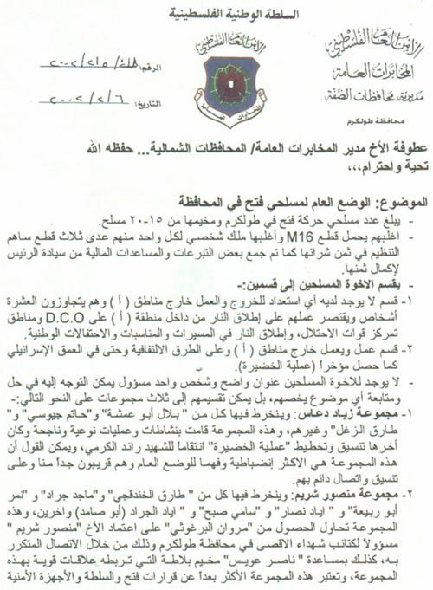

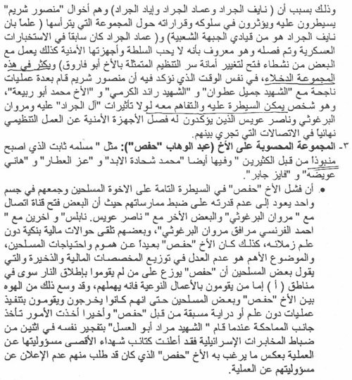

Translation:
Palestinian Authority Captured Document (IDF, 4 April 2002, TR1-248-02)
Palestinian General Security
General Intelligence
West Bank Districts Directorate
Tulkarm District
To Head of General Intelligence/Northern Districts (note: meaning Tawfik Tirawi)
Greetings,
Subject: The General Situation Among Armed Fatah Personnel in the District (Tulkarm)
1. The number of armed Fatah men in Tulkarm and in its refugee camp ranges between 15-20.
2. Most of them (the arms bearers) have M-16 assault rifles, privately owned by each, except for three rifles that the Tanzim took part in their purchase. Additionally contributions were raised and financial aid obtained from the honorable President (Arafat) to complete their cost (purchasing expenses).
3. The armed comrades are divided into two squads:
a. The part that is not willing to operate outside Area A. Their number is just over ten. Their activity comprises firing from inside Area A at the DCO, firing at areas where the occupation forces are concentrated, and (firing) during rallies and national celebrations (of the Palestinians in the Tulkarm area).
b. The active part whose activity is carried out outside Area A. These operate on bypass roads and even in the depth of Israel, as happened recently in Hadera (note: a lethal attack on January 17, 2002, perpetrated by a terrorist with an explosive belt and a rifle at a Bat-Mitzva party in Hadera; 6 Israeli civilians were killed and 25 injured in the attack).
4. The armed comrades have no clear address and no single person can be turned to for a solution (of their problems) and for keeping track of issues regarding their affairs. The (armed) men can be divided into three squads as follows:
a. The Ziad Da'as squad (this squad): includes Bilal Abu Amsha; Hatem Josi; Tareq al-Zael and other (arms bearers). This squad carried out high quality successful attacks. The last (attack) in this framework was the coordination and planning of the operation in Hadera to avenge the death of the martyr Ra'ad Karmi. It would be fair to say that this squad is the most disciplined, and its men understand the general situation. Its men are very close to us (i.e. to the General Intelligence) and maintain with us continuous coordination and contact.
b. The Mansour Sharim squad (note: he is a senior activist in a Fatah cell in Tulkarm, and linked to numerous terrorist attacks):-
(1) It contains Tarek al-Hundakji; Majid Jarad; Nimer Abu Rabi; Iyad Nasser; Sami Sabah, Iyad al-Jarad (Abu Samad) and others.
(2) This squad, by means of repeated contacts with Marwan Barghuti, is attempting to obtain Marwan Barghuti's approval to appoint Mansour Sharim as head of the Al Aqsa Martyrs Brigades in the Tulkarm district. Additionally, this squad operates with the aid of Nasser Awis, a resident of Balata refugee camp, who is closely connected to it (note: known as a senior Fatah activist in Nablus, one of the directors of terrorism of Fatah/Tanzim in Tulkarm).
(3) This squad is considered very remote from the decisions of the Fatah, the PA and the security apparatuses. This, since Naif al Jarad is among the commanders of the "Democratic Front", and since Imad al-Jarad served in the past in the military intelligence, was dismissed from it, and it is known that he does not like the PA and its security apparatuses. In addition, he (Imad al-Jarad) is working together with several Fatah activists to replace the Tanzim secretariat represented by comrade Abu Faruk (note: meaning Fa'ak Kanaan, secretary general of the Tanzim in Tulkarm).
(4) This squad does include a large number of undesirables. However, we would like to emphasize that Mansour Sharim carried out several successful operations together with the martyr Jamil Atwan, the martyr Al-Karmi and comrade Muhamed Abu Rabi. Mansour Sharim is a person who could be controlled and with whom understandings can be reached, if it were not for the (bad) influence on him of the Al Jarad family, of Marwan Barghuti and Nasser Awis by means of the ties maintained between them. The above emphasize to him the total disconnection of the security apparatuses from the organizational activities.
c. The squad identified with Abd Al Wahab (nicknamed) "Hafez" (note: known as a Tanzim activist, head of a squad that operates in Tulkarm). Among its men are Masalame Thabet, who has become a rejected and disliked person; Muhamad Shahade Al Abed; Az Al Atar; Hani Awisa and Faiz Jaber. Hafez's failure to maintain total control of the armed bearers and unite them into one entity derives from his inability to control their activities. Some of his men opened a communications channel with Marwan Barghuti, others with Nasser Awis from Nablus, and others with Ahmed Al Franci, Barghuti's escort (note: meaning Ahmed Al Barghuti, nicknamed "Al Franci", known to be Barghuti's personal aid). Some received bank transfers without this being known to others. "Hafez" is not interested in the needs of the arms bearers. It is important to note that the allocation of the financial resources and ammunition is carried out unfairly. Some of the arms bearers claim that "Hafez" distributes (money and ammunition) only to those who fire from Area A. On the other hand, he neglects those who carry out high quality attacks (i.e. operations inside Israel). The chasm between "Hafez" and some of those armed men (of Fatah) has widened to the extent that they (the arms bearers) used to depart to carry out operations without notifying "Hafez" about them in advance. Recently, these matters have come to a head, so that when the martyr Murad Abu Al Asel blew himself up on two Israeli intelligence officers, the "Al Aqsa Martyrs Brigades" claimed responsibility for the attack against "Hafez"'s will, who requested them not to take responsibility for the operation.
5. Recently the Preventive Security Apparatus (headed by Jibril Rajoub) started to deal with the issue of the arms bearers by means of Akrama Thabet, who serves in the GHQ of the Preventive Security in Ramallah. He (Akrama) carried out several arrangements and coordinations between Hafez and Col. Jibril Rajoub, who recently arranged that one of the wealthy people cover the expenses of Raíad al Karmi's family -- his pregnant wife and his daughter.
6. Between the arms bearers (of Fatah) and the security apparatuses in the district (Tulkarm) several problems arose. The approach of the arms bearers, when those problems arose was one of defiance and law breaking. Among some of the security apparatuses this gave rise to a negative attitude regarding the armed persons of the Fatah. In some cases this reached a complete breakdown of relations (between the security apparatuses and) the armed persons and lack of (joint) work with them. All this at a time when the concept developed whereby the arms bearers of the Fatah constitute first and foremost a staff and support for the Palestinian Authority and its security apparatuses. The strange thing in this context is that the arms bearers stand unified vis-a-vis any problem (arising) with the security apparatuses. Additionally, all turn to brother Hafez in order to urge him to manage matters. However, after a solution is found for the problem (created with the security apparatuses), the arms bearers return to the factions prevailing in their midst.
7. Among the armed squads there are many parasites and people with narrow interests who suddenly appeared in their ranks. It is of note that these did not carry out a single quality operation, while at the same time they took an active part in any problem that arose with the security apparatuses. Additionally, the fact that they bear arms and wander around with them in the streets has become an aim in itself and this is in order to escape their social, organizational and psychological crises. These people have become a financial onus on the organization, since they demand financial allocations, ammunition needs and so on.
8. We believe, on the basis of our experience with our arms bearing brothers that none of the three squads mentioned is not accepting the leadership and responsibility of any of those persons. Marwan Barghuti had a significant role in their situation reaching this level since (Barghuti) assured everybody who contacted him, that the responsibility of the brigades (the "Al Aqsa Martyrs Brigades") in Tulkarm will be his if he works and proves that he worthy of it. The recent activities (of the arms bearers) was conducted in this trend.
9. Amongst the Fatah arms bearers are comrades who stand out in their activity, their affiliation to Fatah, and their understanding of the political situation and what is required in each political stage. In addition, the approach of the security apparatuses and their workers is positive, and their personal daily behavior in the street and amongst the people is characterized by friendship, honor and a positive approach, without creating problems.
10. The Tanzim secretariat (in Tulkarm) provides, through Abu Farouq, sums of money which are taken from the Tanzim budget and from the emergency budget for the allocations to the arms bearers (note: the "emergency" budget -- the intention is apparently to the budget transferred by the PA leadership through the emergency committee headed by Hikham Bilawi). On a number of occasions, severe financial disagreements arose between Abu Farouq and "Hafez" due to the minimal sum allocated to the Tanzim arms bearers. Abu Farouq emphasized on a few occasions that he is interested (to pay) only in special cases to a number of persons who are credited with participation in the struggle and who carried out quality activities, and will not (pay) all arms bearers.
11. Proposals and recommendations:
a. The quality personnel amongst the arms bearers should be selected and assembled under one umbrella (and in the framework) of one group in order to train them for future activity. They should be given special attention from the material, morale and organizational aspects. These main arms bearers include: Ziad Da'as, Bilal Abu Amsha, Tareq Khandakji, Hashem, Kana'an, Tareq Al Za'el and Mansour Sharim.
b. It is necessary to remove some of the parasites who mixed in with the arms bearers and those who did not fire one projectile at Israelis, in order to discard their financial burden and the problems which they cause.
c. Contacts should be made with the commanders of the organizations regarding cooperation so that the handling of the issue of the arms bearers in Tulkarm will be carried out vis-a-vis one man, and that there should not be simultaneous contacts and coordination with a number elements (amongst the arms bearers).
d. If the candidate to assume the responsibility regarding the arms bearers is indeed the comrade "Hafez", he must remove the parasites among them, since their behavior will have a detrimental effect on him. In addition, he must draw closer and closer to the prominent figures amongst the arms bearers so that they will not have to seek other sources of supplies, support and cover, as is taking place at present in Tulkarm.
12. For your information.
Head of the (General) Intelligence in the Tulkarm District
Hamdi Al Darduch
(Signature)

